Project Planning
Project Planning Phase — Product Backlog, Sprint Planning, Stories, Story Points
Date | 25 January 2026
Team ID | SWTID-2026-8588
Project Name | SmartLender
Team Size | 5
Team Leader | Sri Krishna Sai Pavan Goli
Team Members | Maroju Bhanu Prasad, Satya Narayana, Jagadeesh Sai Kalyan Khandavilli, Veedhi Ranadheer Kumar
Maximum Marks | 5 Marks

Product Backlog & Sprint Schedule
Sprint | Functional Requirement (Epic) | USN | User Story / Task | Story Points | Priority | Team Member
Sprint-1 | Registration | USN-1 | As a user, I can register by entering my name, email, phone and password. | 2 | High | Sri Krishna Sai Pavan Goli
Sprint-1 | Registration | USN-2 | As a user, my password is securely hashed with bcrypt before it is stored. | 1 | High | Maroju Bhanu Prasad
Sprint-1 | Login | USN-4 | As a user, I can log in and receive a JWT token to access protected pages. | 2 | High | Satya Narayana
Sprint-1 | Registration | USN-3 | As a user, I receive a clear error if my email is already registered. | 2 | Low | Jagadeesh Sai Kalyan Khandavilli
Sprint-2 | Loan Application Intake | USN-5 | As a user, I can submit my income, employment and credit details for assessment. | 3 | High | Veedhi Ranadheer Kumar
Sprint-2 | Document Upload | USN-6 | As a user, I can securely upload my KYC and income-proof documents. | 2 | Medium | Sri Krishna Sai Pavan Goli
Sprint-2 | ML Prediction | USN-7 | As a user, I can submit my application and instantly receive an approval prediction. | 3 | High | Maroju Bhanu Prasad
Sprint-3 | Loan Recommendation | USN-8 | As a user, I can view a recommended loan product suited to my profile. | 2 | Medium | Satya Narayana
Sprint-3 | Application Review | USN-9 | As a loan officer, I can view an application along with its ML prediction and risk score. | 3 | High | Jagadeesh Sai Kalyan Khandavilli
Sprint-3 | Fraud Flagging | USN-10 | As a loan officer, I can see applications flagged for possible inconsistency. | 2 | Medium | Veedhi Ranadheer Kumar
Sprint-4 | Admin Panel | USN-11 | As an admin, I can view all registered users and applications platform-wide. | 2 | High | Sri Krishna Sai Pavan Goli
Sprint-4 | Analytics | USN-12 | As an admin, I can view aggregate approval-rate and risk-distribution statistics. | 2 | Medium | Maroju Bhanu Prasad

Project Tracker, Velocity & Burndown
Sprint | Total Story Points | Duration | Start Date | End Date (Planned) | Story Points Completed
Sprint-1 | 7 | 6 Days | 02 Feb 2026 | 07 Feb 2026 | 7
Sprint-2 | 8 | 6 Days | 09 Feb 2026 | 14 Feb 2026 | 8
Sprint-3 | 7 | 6 Days | 16 Feb 2026 | 21 Feb 2026 | 7
Sprint-4 | 4 | 6 Days | 23 Feb 2026 | 28 Feb 2026 | 4
Across the four sprints, the team planned and completed 26 story points on schedule, taking SmartLender from registration and login through loan-application intake, ML-based prediction, officer review/fraud flagging, and the admin analytics panel.
Burndown Chart
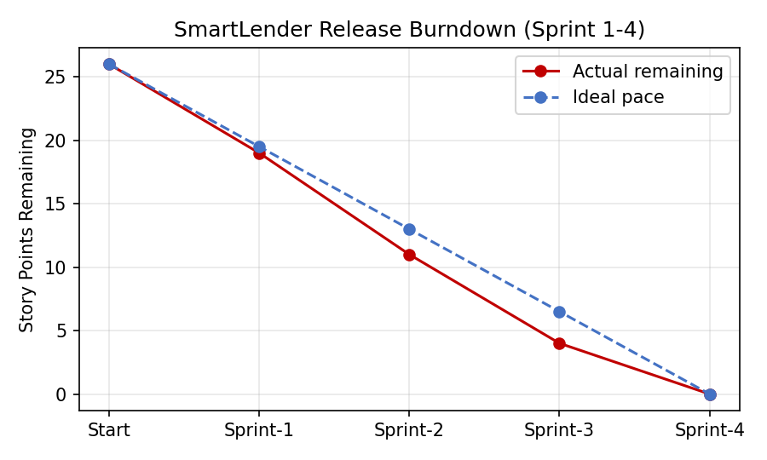
Figure: SmartLender release burndown across Sprint 1–4, story points remaining vs. ideal pace

